Ga-wun Kim

ENGR 250

Scott Koss

Lab Partners: Rebecca, Kantas

Digital Logic Design Lab #1

**Introduction**

I learned how to use “the Power Supply” and “Multimeters” before. However, I forgot how to use them. However, from this lab, these experiments gave a chance to us to remind how to use them. Also, we could learn about “Oscilloscope” and “Function generator instruments” for the first time and realized what their functions are and how to use them.

**Experiment 1**

1. The Power Supply

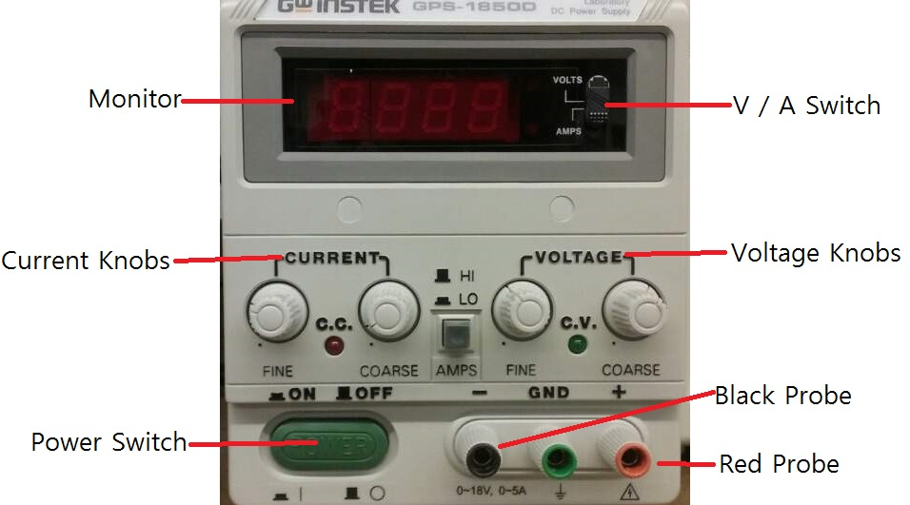

Above picture is the Power Supply.

* Power Switch is the green oval (Bottom-left side). We can turn on and off this machine by this green button.
* We should connect the positive one to Red Probe, and the negative one to Black Probe. Red is for VCC connection and Black is for ground connection. Also, green one (GND) is Safety Ground.
* We can change the value of voltage and current by Current Knobs and Voltage Knobs. The left knob is for the slight change for the value. The right knob is for the large change for the value.
* Monitor displays the voltage / current are power supply is providing.
* V / A Switch change the units and value on display between voltage and current.

1. The Multimeters

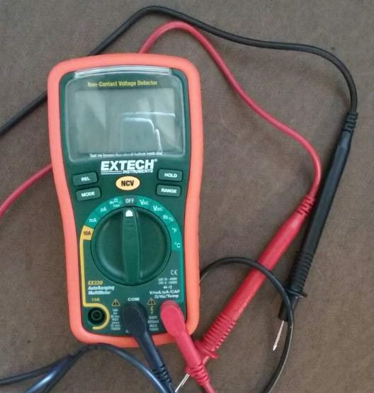

Above picture is the front part of the Multimeters.

* If we change the Measurement Switch (turn right or left), this machine will be turned on.
* The order of the measurement switch is same with below (from left to right).

10A -> mA -> uA -> diode / Ω / beep / CAP -> off -> V AC -> VDC -> Hz -> ºF ->ºC

* In this machine, there are three main functions to measure the value of voltage, current, and resistor. For measuring, we need to change the condition of the measurement switch.
* In generally, black probe is put on the middle spot, and red one is put on the right side. However, when we need to measure around 10A, we need to change the red probe from right side to left. Black probe is for ground (-) , Red probe is for (+).

1. The Function Generator

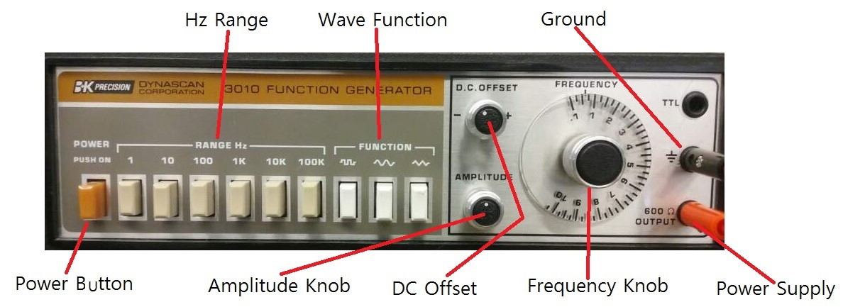

Above picture is the front part of the function generator.

We can turn on and off this function generator by Power button.

We can change the Hz by “Range Hz”. (1Hz, 10Hz, 100Hz, 1kHz, 10kHz, and 100kHz)

We can change the wave functions (Square wave, Sin wave, and Triangle wave).

We can control the vertical length of the wave by Amplitude Knob.

DC offset is a mean amplitude displacement from zero.

1. The oscilloscope

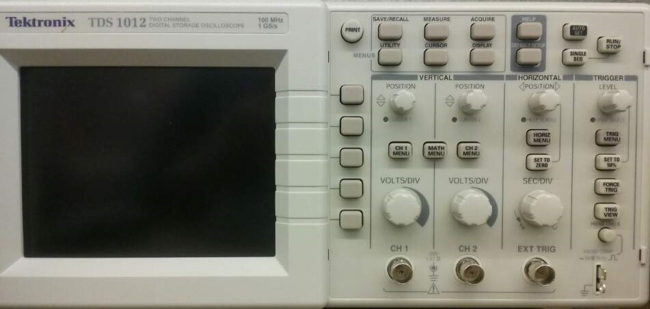

Above picture is the front part of the Oscilloscope. With this item, we can change the vertical control, horizontal control, time domain control, and so on.

* When we want to reset the setting and to change the display to initial thing, we can change that by “Auto Set”. This is kind of default setting.
* There are three main functions to change the point of view about the graph by Vertical (Ch1, Ch2) Horizontal, and Trigger
* By Position knobs, we change the position of each side. Also, the level in Trigger has a similar function with position knobs. However, we need to put this point between the graph ranges to observe the graph exactly. If we put the point out of range, the graph is moving, continuously.
* By VOLTS/DIV knobs, we can alter the one unit in the graph.

**Experiment 2**

For this experiment, we connected the Function Generator with an Oscilloscope. We used the function generator for changing the options: frequency, amplitude, and so on. Also, Oscilloscope was used as screen for interaction. In this experiment, we set like that options.

1 KHz frequency / 50% duty cycle / amplitude to 5V peak to peak / DC Bias of 2.5V

Our expectation (before this experiment) about the graph met with the actual graph.

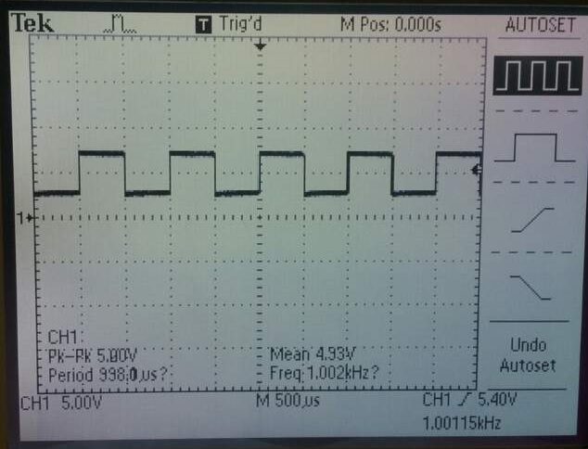

**Experiment 3**

In this experiment, we set like that options

10 Hz frequency / 50% duty cycle / amplitude to 5V peak to peak / DC Bias of 2.5V

Before this experiment, we guessed that the one cycle of the graph would be longer than the before experiment. This is because we set the different frequency in this experiment.

(1 kHz -> 10 Hz)

After this experiment, we could know that the actual graph and our expectation about the graph are similar.

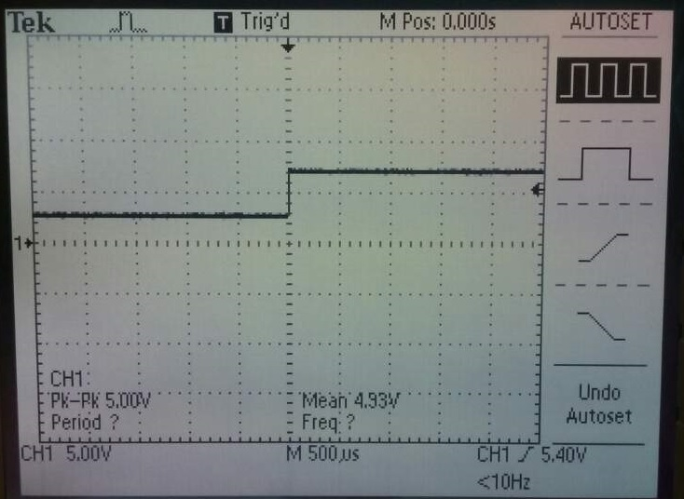

**Experiment 4**

In this experiment, we set like that options.

The Function Generator’s Maximum frequency / 50% duty cycle / amplitude to 5V peak to peak / DC Bias of 2.5V

In this experiment, we did not change “Ranger Hz” buttons and only arranged “Frequency Knob” to the Maximum value.

Before this experiment, we guessed that the one cycle of the graph would be shorter than the experiment 2. This is because we set the different frequency. (1 kHz -> max Hz)

After this experiment, we could know that the actual graph and our expectation about the graph are similar.

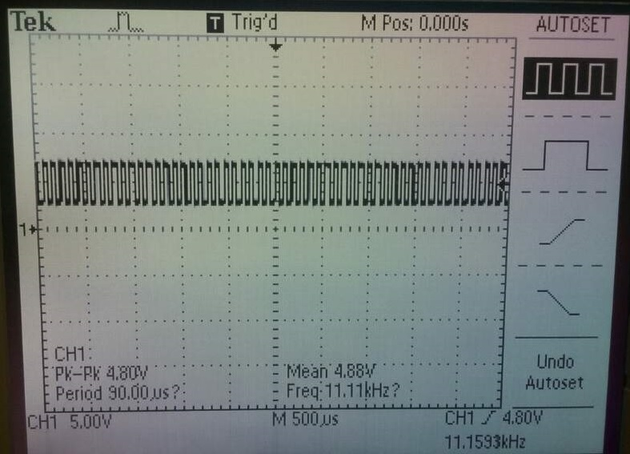

**Experiment 5**

In this experiment, we used “Multimeters”. We inserted the Multimeters’ probes into the each hole in the proto board to look for the connectivity.

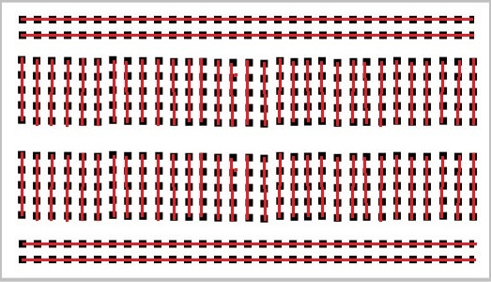

**Experiment 6**

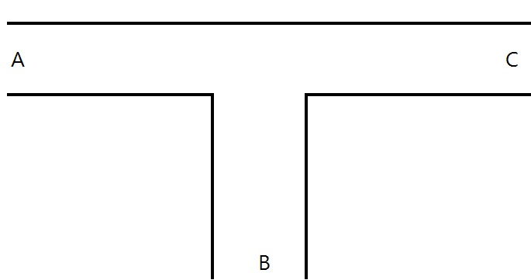

Car Position: Car = 1 / No Car = 0

Traffic lights: Green light =1 / Red light = 0

|  |  |  |  |  |  |
| --- | --- | --- | --- | --- | --- |
| Car Position | | | Traffic Lights | | |
| A sensor | B sensor | C sensor | L(A) | L(B) | L(C) |
| 0 | 0 | 0 | 1 | 0 | 1 |
| 0 | 0 | 1 | 1 | 0 | 1 |
| 0 | 1 | 0 | 1 | 0 | 0 |
| 0 | 1 | 1 | 1 | 0 | 1 |
| 1 | 0 | 0 | 0 | 1 | 1 |
| 1 | 0 | 1 | 1 | 0 | 1 |
| 1 | 1 | 0 | 1 | 0 | 0 |
| 1 | 1 | 1 | 1 | 0 | 1 |

Lessons learn from lab 1 are:

Remind how to use Multimeters and Power Supply.

Remind the connectivity of proto-board.

Learn about Oscilloscope and function generator.

I think that this lab 1 was basic experiment for all students to take ENGR 250. For this reason, it was easy to do experiment without effort. However, we spent a lot of time to learn these machines. This is because, without the sufficient understanding about these machines, I think it would be hard to be successful in other labs. Specifically, before this lab, we did not have any idea about Oscilloscope and Function Generator so that we strived to get used to them.